RESERVATION FORM
AIM (Association des Ingénieurs de Montefiore)
reservations@ramadaplaza-liege.com
29/05/2016-03/06/2016

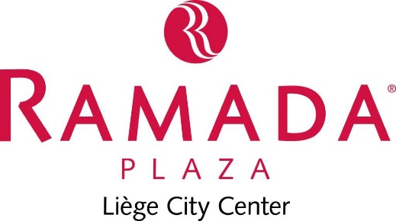

Click the box
29/05/2016 – 03/06/2015 ROOMS
- 89,00€ single room
(breakfast included + 2,50€ City tax/pers./night)
- 99,00€ double room
(breakfast included + 2,50€ City tax/pers./night)

NAME …………………………………………………………
(COMPANY) ………………………………………………
ADDRESS …………………………………………………..
…………………………………………………………………...
…………………………………………………………………….
TEL ………………………………………………………………
EMAIL ………………………………………………………....
All reservations must be guaranteed by credit card.
I CONFIRM THE RESERVATION BY : AMEX – VISA – DINERS – MASTERCARD
Type of credit card
Credit card number
Expiry date | Code CVC :

SIGNATURE
This reservation is guaranteed for late arrival. If you would like to cancel this reservation you can do so before 6PM on the day of arrival without any costs. In case of non arrival and no cancellation before 6PM, the first night will be charged.

